

**e-merge ::**

**morning**

**money**

**master-mind**



What if you rolled out of bed into your abundant joy?

Mornings Every Week-Day for 21 Days (see current schedule)

Emerging together our ever- expansive, loving lives

Access to ease, joy and expressive abundance.

What would it take to be your masterful self & make more money?

How would you express your glorious abundance? 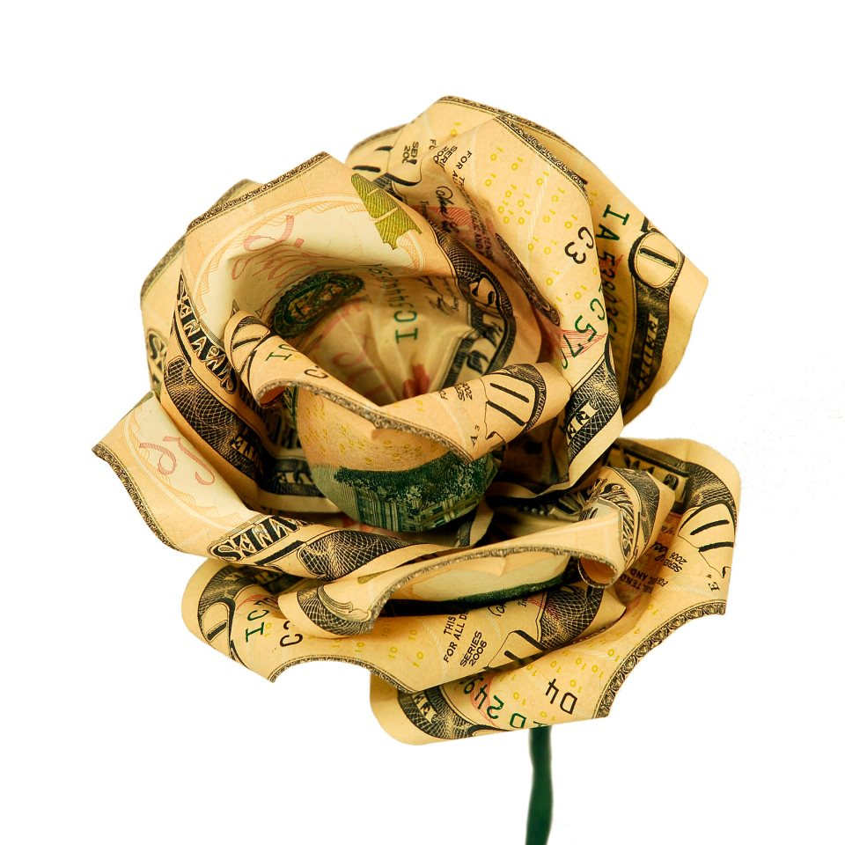

**This call-in series is for you if you……..**

Are sooo!! ready to receive the warm light of connectedness with others ?

Are you willing to receive abundant gifts of ease and joy and freedom from worry about making money ?

What would it take to have your expressive heart sing ?

What would it take to be your masterful self & make more money?

What kind of expansive, productivity can possibly happen on a phone call?

**Here’s what each call will look like –** Callinto the phone number and tap in your passcode (received after registration).

**enter** the communal space of each day’s unique spiritual vibration – 4 minutes



**empty** of judgments we impose on ourselves & others– 5 minutes

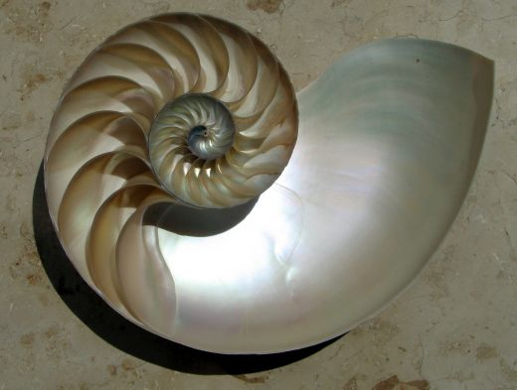

**express** gratitude for our radiant right livelihood – 2 minutes

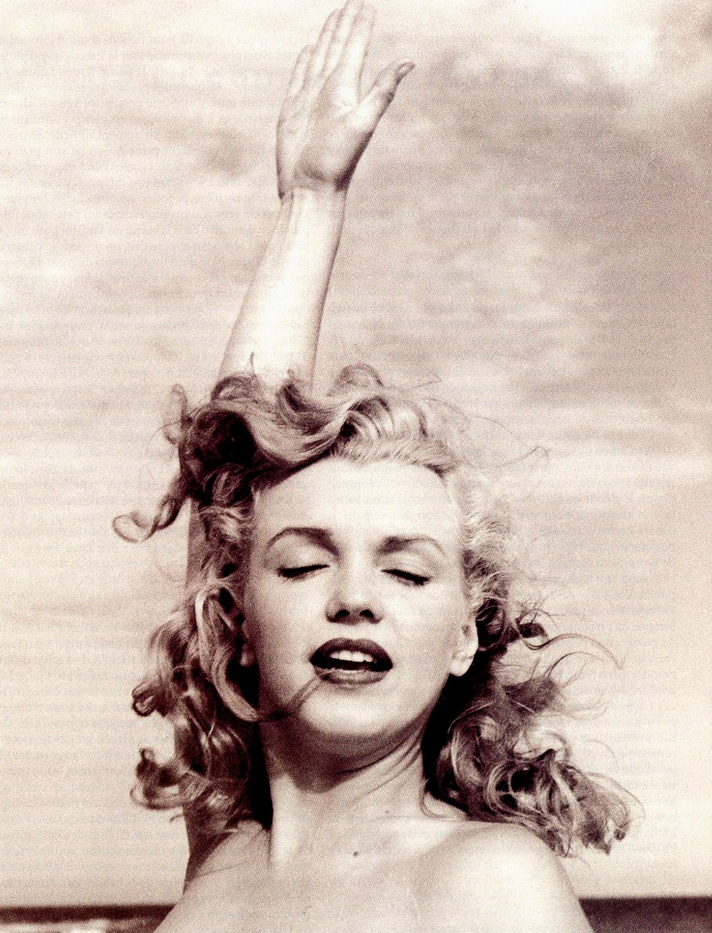

Who is this woman?

**embrace** being congruent, releasing resistance and allow receiving – 4 minutes to share in the discovery and wisdom of Mastermind –ness!

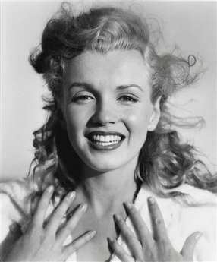

MY Creative Economy Enterprises’ PROMISES:

You will experience a sense of belonging and connectedness to others every day.

An unexpected money opportunity opens for you this month.

|  |
| --- |
| **Purple Waterfall.jpg** |

You will rediscover being called to your right destiny in this moment of time.

REGISTER NOW Call Dawn S. Mazzone - 610.636.0279 for current program dates

Early Bird Registration @ $ 55

Registration starting @ $ 75

VIP Registration @ $ 97 includes a 20 min. one on one phone session using color to go deeper.

Please note, it is highly recommended to be on each call. Miracles happen when a new pattern is established for 21 days in a row. If, however, an unforeseen circumstance prevents you from attending one morning, you’ll easily start again the next day! 

*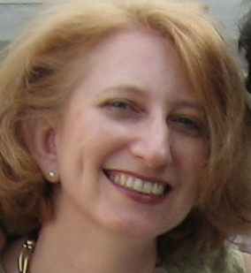 Dawn S. Mazzone, Social Entrepreneur* Founder of Creative Economy Enterprises, LLC.

Creative Economy Enterprises is a programs and resource marketplace to l*eap* us

into the new spirit of collaboration, interconnection and natural abundance,

mindful of what we individually need for expressing meaning and contribution to life,

and attentive to what the world needs for the well being of all, Creative Economy Enterprises

are those that engage us at the core of “What it means to be human” in these times.